**A**

***PROJECT REPORT***

*on*

***Food Ordering website***

*Submitted in partial fulfilment of the requirements for the degree of*

**BACHELOR OF TECHNOLOGY**



Session: - 2024

Under Guidance of

Mr. Aaditya Maheshwari Assistant Professor

Dept. of CSE TINJRIT, Udaipur

Submitted by

Vishal Sharma (20ETCCS116) Rohan Shekhawat(20ETCCS096) Harsh Menon (20ETCCS046) Gouri Kumawat (20ETCCS043) Dhruv Kumar Singh (20ETCCS303)

Devraj Singh Gehlot (20ETCCS031)

**DEPARTMENT OF COMPUTER SCIENCE AND ENGINEERING TECHNO INDIA NJR INSTITUTE OF TECHNOLOGY, UDAIPUR-313001 2024**

**A**

##### PROJECT REPORT

*On*

#### Food Ordering system

*Submitted in partial fulfilment of the requirements for the degree of*

#### BACHELOR OF TECHNOLOGY



**Session: - 2024**

Under Guidance of

Mr. Aaditya Maheshwari Assistant Professor

Dept. of CSE TINJRIT, Udaipur

Submitted by

Vishal Sharma (20ETCCS116) Harsh Menon(20ETCCS046) Rohan Shekhawat (20ETCCS096) Gouri Kumawat(20ETCCS043) Dhruv Kumar Singh (20ETCCS303)

Devraj Singh Gehlot (20ETCCS031)

8th Sem (CSE)

**DEPARTMENT OF COMPUTER SCIENCE AND ENGINEERING**



Department of Computer Science and Engineering Techno India NJR Institute of Technology, Udaipur-313001

## Certificate

This is to certify that project work titled **Food Ordering system** by **Vishal Sharma** was successfully carried out in the Department of Computer Science and Engineering, TINJRIT and the report is approved for submission in the partial fulfillment of the requirements for award of degree of Bachelor of Technology in Computer Science and Engineering.

Mr. Aaditya Maheshwari Dr. Rimpy Bishnoi

Assistant Professor Head of Department

Dept. of CSE TINJRIT, Udaipur Dept. of CSE TINJRIT, Udaipur

Date Date



Department of Computer Science and Engineering Techno India NJR Institute of Technology, Udaipur-313001

## Certificate

This is to certify that project work titled **Food Ordering system** by **Harsh Menon** was successfully carried out in the Department of Computer Science and Engineering, TINJRIT and the report is approved for submission in the partial fulfillment of the requirements for award of degree of Bachelor of Technology in Computer Science and Engineering.

Mr. Aaditya Maheshwari Dr. Rimpy Bishnoi

Assistant Professor Head of Department

Dept. of CSE TINJRIT, Udaipur Dept. of CSE TINJRIT, Udaipur

Date Date



Department of Computer Science and Engineering Techno India NJR Institute of Technology, Udaipur-313001

## Certificate

This is to certify that project work titled **Food Ordering system** by **Rohan Pratap Singh Shekhawat** was successfully carried out in the Department of Computer Science and Engineering, TINJRIT and the report is approved for submission in the partial fulfillment of the requirements for award of degree of Bachelor of Technology in Computer Science and Engineering.

Mr. Aaditya Maheshwari Dr. Rimpy Bishnoi

Assistant Professor Head of Department

Dept. of CSE TINJRIT, Udaipur Dept. of CSE TINJRIT, Udaipur

Date Date



Department of Computer Science and Engineering Techno India NJR Institute of Technology, Udaipur-313001

## Certificate

This is to certify that project work titled **Food Ordering system** by **Gouri Kumawat** was successfully carried out in the Department of Computer Science and Engineering, TINJRIT and the report is approved for submission in the partial fulfillment of the requirements for award of degree of Bachelor of Technology in Computer Science and Engineering.

Mr. Aaditya Maheshwari Dr. Rimpy Bishnoi

Assistant Professor Head of Department

Dept. of CSE TINJRIT, Udaipur Dept. of CSE TINJRIT, Udaipur

Date Date



Department of Computer Science and Engineering Techno India NJR Institute of Technology, Udaipur-313001

## Certificate

This is to certify that project work titled **Food Ordering system** by **Dhruv Kumar Singh** was successfully carried out in the Department of Computer Science and Engineering, TINJRIT and the report is approved for submission in the partial fulfillment of the requirements for award of degree of Bachelor of Technology in Computer Science and Engineering.

Mr. Aaditya Maheshwari Dr. Rimpy Bishnoi

Assistant Professor Head of Department

Dept. of CSE TINJRIT, Udaipur Dept. of CSE TINJRIT, Udaipur

Date Date



Department of Computer Science and Engineering Techno India NJR Institute of Technology, Udaipur-313001

## Certificate

This is to certify that project work titled **Food Ordering system** by **Devraj Singh Gehlot** was successfully carried out in the Department of Computer Science and Engineering, TINJRIT and the report is approved for submission in the partial fulfillment of the requirements for award of degree of Bachelor of Technology in Computer Science and Engineering.

Mr. Aaditya Maheshwari Dr. Rimpy Bishnoi

Assistant Professor Head of Department

Dept. of CSE TINJRIT, Udaipur Dept. of CSE TINJRIT, Udaipur

Date Date

## Examiner Certificate

This is to certify that the following student **Vishal Sharma,** Final year B.Tech. (Computer Science and Engineering), was examined for the project work titled **FOOD ORDERING SYSTEM** during the academic year 2023 – 2024 at Techno India NJR Institute of Technology, Udaipur.

#### Remarks:

**Date:**

Signature Signature

(**Internal Examiner**) (**External Examiner**)

Name :- Name :-

Designation:- Designation:-

Department: - Department: -

Organization:- Organization:-

## Examiner Certificate

This is to certify that the following student **Harsh Menon,** Final year B.Tech. (Computer Science and Engineering), was examined for the project work titled **FOOD ORDERING SYSTEM** during the academic year 2023 – 2024 at Techno India NJR Institute of Technology, Udaipur.

#### Remarks:

**Date:**

Signature Signature

(**Internal Examiner**) (**External Examiner**)

Name :- Name :-

Designation:- Designation:-

Department: - Department: -

Organization:- Organization:-

## Examiner Certificate

This is to certify that the following student **Gouri Kumawat,** Final year B.Tech. (Computer Science and Engineering), was examined for the project work titled **FOOD ORDERING SYSTEM** during the academic year 2023 – 2024 at Techno India NJR Institute of Technology, Udaipur.

#### Remarks:

**Date:**

Signature Signature

(**Internal Examiner**) (**External Examiner**)

Name :- Name :-

Designation:- Designation:-

Department: - Department: -

Organization:- Organization:-

## Examiner Certificate

This is to certify that the following student **Rohan Pratap Singh Shekhawat,** Final year B.Tech. (Computer Science and Engineering), was examined for the project work titled **FOOD ORDERING SYSTEM** during the academic year 2023 – 2024 at Techno India NJR Institute of Technology, Udaipur.

#### Remarks:

**Date:**

Signature Signature

(**Internal Examiner**) (**External Examiner**)

Name :- Name :-

Designation:- Designation:-

Department: - Department: -

Organization:- Organization:-

## Examiner Certificate

This is to certify that the following student **Devraj Singh Gehlot,** Final year B.Tech. (Computer Science and Engineering), was examined for the project work titled **FOOD ORDERING SYSTEM** during the academic year 2023 – 2024 at Techno India NJR Institute of Technology, Udaipur.

#### Remarks:

**Date:**

Signature Signature

(**Internal Examiner**) (**External Examiner**)

Name :- Name :-

Designation:- Designation:-

Department: - Department: -

Organization:- Organization:-

## Examiner Certificate

This is to certify that the following student **Dhruv Kumar Singh,** Final year B.Tech. (Computer Science and Engineering), was examined for the project work titled **FOOD ORDERING SYSTEM** during the academic year 2023 – 2024 at Techno India NJR Institute of Technology, Udaipur.

#### Remarks:

**Date:**

Signature Signature

(**Internal Examiner**) (**External Examiner**)

Name :- Name :-

Designation:- Designation:-

Department: - Department: -

Organization:- Organization:

## ACKNOWLEDGMENT

We take this opportunity to record our sincere thanks to all who helped us to successfully ssssscomplete this work. Firstly, we are grateful to our **supervisor Mr. Aaditya Maheshwari.**

for his invaluable guidance and constant encouragement, support and most importantly for giving us the opportunity to carry out this work.

We would like to express our deepest sense of gratitude and humble regards to our **Head of Department Dr. Rimpy Bishnoi** for giving invariable encouragement in our endeavors and providing necessary facility for the same. Also a sincere thanks to all faculty members of CSE, TINJRIT for their help in the project directly or indirectly. Finally, we would like to thank my friends for their support and discussions that have proved very valuable for us. We are indebted to our parents for providing constant support, love and encouragement. We thank them for the sacrifices they made so that we could grow up in a learning environment. They have always stood by us in everything we have done, providing constant support, encouragement and love

**Vishal Sharma (20ETCSS023)**

**Harsh Menon (20ETCCS090) Rohan Pratap Singh Shekhawat (20ETCCS042) Gouri Kumawat(20ETCCS073) Devraj Singh Gehlot(20ETCCS031) Dhruv Kumar Singh(20ETCCS303)**

**DEPARTMENT OF COMPUTER SCIENCE AND ENGINEERING TECHNO INDIA NJR INSTITUTE OF TECHNOLOGY, UDAIPUR-31300**

## CONTENTS

|  |  |
| --- | --- |
| **Name of Contents** | **Page no.** |
| Certificate | 2-8 |
| Examiner Certificate | 9-14 |
| Acknowledgements | 15 |
| Contents | 16 |
| List of Figures | 17 |
| Chapter 1: Introduction | 18 |
| Chapter 2: System Analysis and Design | 21 |
| Chapter 3: System Specification | 29 |
| Chapter 4: Development | 39 |
| Conclusion | 66 |
| Future Scope | 66 |
| Bibliography | 67 |

List of figures

|  |  |
| --- | --- |
| Figure number | Page Number |
| 1.1 | 27 |
| 1.2 | 28 |
| 1.3 | 34 |
| 1.4 | 42 |
| 2.1 | 44 |
| 2.2 | 44 |
| 2.3 | 45 |
| 24 | 45 |
| 2.5 | 46 |
| 2.6 | 46 |
| 3.1 | 48 |
| 3.2 | 50 |
| 3.3 | 51 |
| 3.4 | 52 |
| 3.5 | 53 |
| 3.6 | 54 |
| 3.7 | 55 |
| 3.8 | 56 |
| 3.9 | 57 |
| 3.10 | 58 |
| 3.11 | 58 |
| 3.12 | 59 |
| 3.13 | 60 |
| 3.14 | 62 |
| 4.1 | 63 |
| 4.2 | 64 |

### CHAPTER 1: INTRODUCTION

**Name of the project: Food Ordering system General Introduction**

In India and other nations, the usage of online food ordering is a significant and expanding industry. Manual food purchasing is now quite taxing and takes a lot of time because one must wait in a long line. The issue of food ordering among locals in the nation must therefore be addressed with an effective mechanism. Visitors can use the web-based ordering system to place meal orders that suit their preferences, moods, or needs.

Customers can order food via the web-based Online Food Ordering application depending on their preferences. Once the administrator has granted access, this system is set up for all users working for hotels, cafes, restaurants, etc. Online food ordering offers a system that allows customers to place orders with only one click. Users can utilize this system to order food online using a computer or mobile device. Customers can order food using this website by logging onto their accounts. Users don't need to go outside to get food because online food ordering is widely used

#### Project Background ONLINE FOOD ORDERING

Food purchasing was tough for both clients and providers in the offline age. The ability of customers to select various options depending on their taste, mood, and necessity criteria was restricted while ordering food offline. Additionally, it raised the cost of franchising for the food supplier. The food supplier was also having trouble keeping track of their client information at the same time. Many small and medium-sized restaurants lack their own online meal ordering platform. The Online Food Ordering web portal is a complete internet food ordering operation that offers the benefit of the total in-house management of food ordering. It allows you to order food based on location, food type, and cost type criteria. It also allows you to check your previous order details to make your job easier. Additionally, it gives consumers the freedom to choose a meal source based on its popularity, ranking, and reliability. This robust Internet- based meal ordering system enables total control over the site's content as well as the food inventory.

The following is a list of the components of an online meal ordering system web portal that improves service for clients and food ordering:

* Price list,
* Ranking of food providers,
* Filtering based on customer needs,
* Customer information such as name, address, phone number, and e-mail address capture
* Information about payments,
* Contact details, and
* Addresses for the providers are also provided.

## Motivation of the Project

Online food ordering systems are growing in popularity as technology advances. This is so that they can meet the always-growing need for persuasion. Customers need the means to order from restaurants online, which is the core function of an online ordering system. The principal reason is that it is advantageous to both the client and the company. Customers may quickly browse all of the restaurant's dishes, modify them to their specifications, and place orders using a website or mobile app. Additionally, it can save their favorite orders so they may quickly order them again in the future.

From the restaurant's standpoint, this means that they no longer have to spend time processing clients' orders, worry less about misunderstandings, and organize their order management process more efficiently.

Traditionally, ordering meals required making phone calls, driving to the restaurant or café, and waiting for the food to be prepared and delivered. The possibility of order errors occasionally exists while placing an order over the phone. These are obviously not the finest ways to order food from restaurants, especially for those who lead busy lives.

The best course of action is to start ordering online. Food providers can utilize a website, an app, or both to expedite restaurant operations as well as the ordering process for customers. An online ordering platform can help restaurants run their daily operations more effectively. On the other hand, when a consumer places an order online, they take their time to read the menu and become familiar with any add-on discounts and offers that your restaurant must be providing. The overall sale value per order may rise exponentially as a result of this.

There are situations where placing a phone call to purchase meals may not be possible, such as during meetings or in crowded places. Customers can place orders online using their smartphones, tablets, or other portable devices at any time and location. There is no need for the client to call and disturb someone's privacy or a conference in order to place an order for lunch. The customer can place an order privately via a mobile app rather than having to speak on the phone. Your website or app will never lose a consumer if it is mobile-friendly.

## Project Overview

In many countries, e-food ordering systems have already been adopted or are in the process of being introduced. Food providers have been attempting to replace takeout with electronic media. Meal is purchased and kept in electronic devices, which is the key feature of food ordering. However, because better service quality is the primary goal of food ordering, the advantages of a thorough food ordering system for food providers are difficult to quantify. Financially speaking, food orders might lower administrative expenses because fewer cashiers would be required, fare processing times would be slashed, and a higher customer throughput would be possible.

Moreover, it would be possible to differentiate prices effectively and eliminate fare evasion and fraud brought on by cash handling. The concept is made more appealing to clients by the ability to better integrate additional services thanks to food ordering. Accurate information on customer flows may also make it easier to better utilize the network's capabilities and enhance the user experience by establishing specialized services for each particular client.

# Chapter 2

## SYSTEM ANALYSIS AND DESIGN

### System Analysis

Systems analysis is the process of gathering factual data, comprehending the processes involved, detecting issues, and making workable recommendations for enhancing system performance. Studying business processes, acquiring operational data, understanding information flow, identifying bottlenecks, and developing solutions to address system shortcomings are all necessary for accomplishing corporate goals. The division of complicated activities encompassing the entire system, the identification of data stores, and manual processes are all included in system analysis.

Finding the answers to the following questions for each business process is the main goal of systems analysis: What is being done, How is it being done, Who is doing it, When is he doing it, Why is it being done, and How can it be improved? It requires the system analyst's creative abilities more than anything else and is more of a thought process. It aims to give birth to a brand-new, effective system that meets the user's immediate needs and has scope for expansion in the future while still operating within organizational restrictions. This technique leads to a logical system design. Systems analysis is an iterative process that keeps going until an ideal and practical solution shows up.

#### Design

Planning a solution to the issue mentioned in the requirement document is the goal of the design phase. This is the initial stage in transitioning from the problem domain to the solution domain. Design starts with the needs and leads us to solutions for meeting them. The quality of the designs has a significant impact on the latter stages, particularly testing and maintenance. The design document is the phase's output.

This document is utilized subsequently during implementation, testing, and maintenance and is used similarly to a blueprint or as a plan for the solution. The design process is frequently split into two distinct phases: system design and detailed design, sometimes referred to as top-level design, which tries to determine which modules should be included in the system, their specifications, and how they interact with one another to produce the intended results.

All the primary data structures, file formats, output formats, and major modules in the system and their requirements are decided at the end of the system design.

## Identification of Project Requirements

Online Food Ordering Systems described above can lead to error-free, secure, reliable, and fast management systems for restaurants and hotels.

It can assist the staff in concentrating on their related (preparation and delivery) activities rather than concentrating on the customer records and other valuable information. This will help food vendors in better utilization of human resources.

In this phase, the user identifies the need and desired requirements for a new or improved system. In large organizations, this identification may be part of a systems planning process.

## Preliminary Investigation

The initial phase of the system development life cycle is the preliminary system study. This brief analysis of the system under discussion offers a clear image of what the physical system is actually like. As a matter of fact, the initial system research entails the creation of a "System Proposal" that outlines the Problem Definition, Objectives of the Study, Terms of Reference for the Study, Constraints, Expected Benefits of the New System, etc., in light of the User Requirements.

The system analyst, after studying the system, creates a system proposal, which is placed before user management. If the management approves, the cycle moves on to the next phase. The management has the option of rejecting the plan or requesting changes. In conclusion, we may conclude that the system study phase involves the following stages:

* + Problem identification and project launch
  + Background investigation
  + conclusions or inferences (system proposal)

## Feasibility Study

If the system idea is accepted by the management, the following step is to analyze the system's feasibility. The main purpose of a feasibility study is to evaluate a proposed

system's viability, user requirements, resource efficiency, and, of course, cost-effectiveness. Technical, operational, economic, and scheduling feasibility are the different categories for these.

The basic objective of a feasibility study is to attain the scope, not to fix the issue. In the feasibility study phase, the costs and benefits are more precisely estimated to determine the Return on Investment (ROI). This outlines the resources required to complete the comprehensive inspection.

A feasibility report is the end outcome, and it is sent to management. This could be approved, approved with changes, or denied. If management approves, the system cycle will only continue.

## Estimate Project Cost and Benefit

The investment in a particular project must be disclosed during project planning. Every project's foundation will be built on this. For one, the investment will determine how much the company will spend to make certain software. This is especially true for businesses that frequently employ project-based developers. How many people will be employed by the project depends on investment? Project planning and feasibility studies should demonstrate the return on investment for the company once the project is completed. If it's only a business tool, it should demonstrate how it can boost employee productivity and have a real financial impact.

#### Feasibility Analysis

Researchers or software advocates will genuinely demonstrate why the software is required in a practical economic sense. A software's suitability for public usage will always be demonstrated by statistical data. Most of the time, researchers will interview individuals to find out if they would use a certain piece of software if it were on the market. It will also look at potential competitors and how the software will differ from those offered by other businesses. It will also look at potential competitors and how the software will differ from those offered by other businesses.

#### Outline the Technical Needs

Developers should be able to identify potential technological requirements for the product during

project planning. These are crucial since it would be practically impossible to construct software without them. Developers should have access to the best tools possible for the duration of the project's development within the constraints of the budget.

## Literature Review

Food ordering web applications have become increasingly popular in recent years, with companies like the website leading the way in the development and implementation of these systems. A literature review of the development of food ordering web applications like The website would examine the various technical, design, and user experience considerations that have been taken into account in the creation of these systems. One key aspect of the development of food- ordering web applications is user experience design. This includes considerations such as the overall layout and navigation of the site, the ease of use of the various features, and the ability for users to easily find and order the food they want. Studies have shown that user experience design is a critical factor in the success of food ordering web applications [1, 2]. Another important aspect of the development of food-ordering web applications is the use of technology. This includes the use of mobile technologies, such as responsive design and mobile optimization, as well as the integration of various payment and delivery systems. Research has shown that the use of technology can greatly improve the efficiency and user-friendliness of food-ordering web applications [3, 4]. Another key aspect of the food ordering web application the restaurant management; it includes the integration of various functionalities such as menu management, order management, inventory management, and analytics. These functionalities will help the restaurant to manage the orders and inventory efficiently. Studies have shown that restaurant management functionalities are crucial for the success of food ordering web applications [5, 6]. In summary, the development of food ordering web applications like The website involves a number of technical, design, and user experience considerations. User experience design, technology integration, and restaurant management functionalities are all important factors in the success of these systems.

## Project Planning

We've discovered how crucial it is to have a social networking plan when constructing websites with a social component. Wireframes and mockups, which are common Web design techniques, are still used in the process, but we have also been developing ideas for social engagement. The secret to developing a good plan is understanding how every social media platform you might be connected with functions. The specifics are crucial. How do you build contacts and

friends? How do group’s function? How can your website be "featured"? Getting featured can result in a lot of traffic.

It is simple to envision how users could misuse the system or otherwise cause issues by being present on a networking site (after all, this may be the single most common excuse keeping museums out of social spaces). We must prepare for the possibility of offensive remarks, whether they be erroneous or worse. However, the process shouldn't be dominated by preparation for these potentially harmful interactions.

## Project Scheduling

In project management, efforts are regarded as the smallest units of work that must be accomplished without fail on time and within the allocated budget. Jobs are carried out in accordance with the project's schedule and budget when they are part of the same assignment and have a meaningful relationship with one another. "Dependencies" refer to the connections between project duties. Process dependence is kept in accordance with project planning and budgeting.

As you can see, each dependent activity's start and end dates are determined by two factors: the start date and the conclusion date. These characteristics must be established for your projects when you create a plan for them, taking into account the different sorts of dependencies. Your timeline might develop into a thorough plan that illustrates the project's action flow. Additionally, you allocate resources in accordance with job requirements, and you create a budget sheet that outlines how the savings should be used during the course of the project.

For instance, MS Project makes use of a Gantt chart to distribute tasks and resources over a timeline.

It is possible to make a plan that illustrates the scheduling and chronology of each action in your project. Another example is Centriqs software, which enables you to specify cost, pricing, rate, or other custom attributes of your choice while scheduling dependent projects on personal calendars. The estimated, actual, and remaining time of one's duties can all be added up using Centriqs.

## Software Requirement Specifications (SRS)

The software development activity begins with the software requirement specification (SRS). This stage wasn't given much attention in the early stages of software development.

As systems got more intricate, it became clear that the overall system's aims were difficult to understand. Consequently, the requirement analysis phase became necessary. Now, requirements analysis is possibly the most challenging and error-prone process when it comes to complex software systems.

The scope of this phase is partly to blame for the problem. The client's requirements drive the software project. These requirements are initially in the ideas of several people in the client business. By speaking with them and learning about their needs, the requirement analyst must determine the requirements. Most requirements can be understood by looking at how things are currently done in cases where software is being used to automate a manual operation.

The SRS is a tool for turning the clients' ideas (the input) into official documents (the output of the requirements phase). Thus, the phase's output is a set of formally described needs that, hopefully, are comprehensive and consistent, whereas the input has none of these features.

The suggested system consists of two main modules:

* + - Customer
      * Visitor
      * Member
    - Track Order

## Data Flow Diagram (DFD)

A Data Flow Diagram (DFD) is a type of diagram that is used to represent the flow of data in a system. It is often used in software engineering, business process modeling, and system analysis to show how data is processed within a system. A DFD is composed of a set of symbols and notation that are used to represent the different components of the system, such as data sources, processes, data stores, and data sinks. The symbols and notation are used to show the flow of data between these components and how they are related. DFDs can be used to represent systems at different levels of abstraction, from a high-level overview of the entire system to a detailed representation of individual processes.

They are useful for identifying and understanding the flow of data within a system, which can help to improve its design and functionality

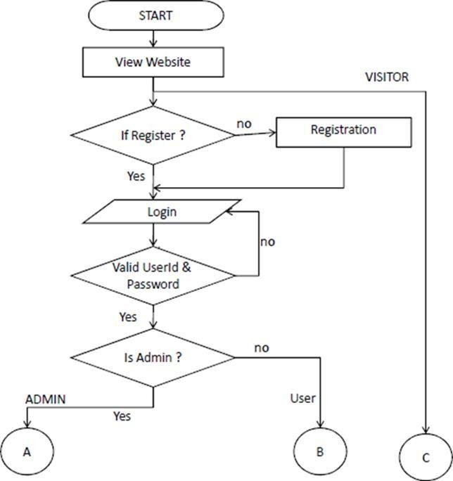

#### Fig 1.1

**USE CASE DIAGRAM**

A use case diagram is a type of Unified Modeling Language (UML) diagram that shows the interactions between actors and use cases in a system. Actors represent external entities that interact with the system, such as users or other systems, while use cases represent the actions or processes that the system can perform. Use case diagrams provide a high-level view of the functionality of a system and are typically used to capture the requirements of a system during the analysis and design phases of software development. Use Case diagrams are a way to express the functionality of a system in a graphical way. They typically include actors, use cases, and the relationships between them. It's used to identify the primary elements and processes that form the system and how they interact with each other. It's an important technique to be used when modeling software systems, but not limited to software systems only.

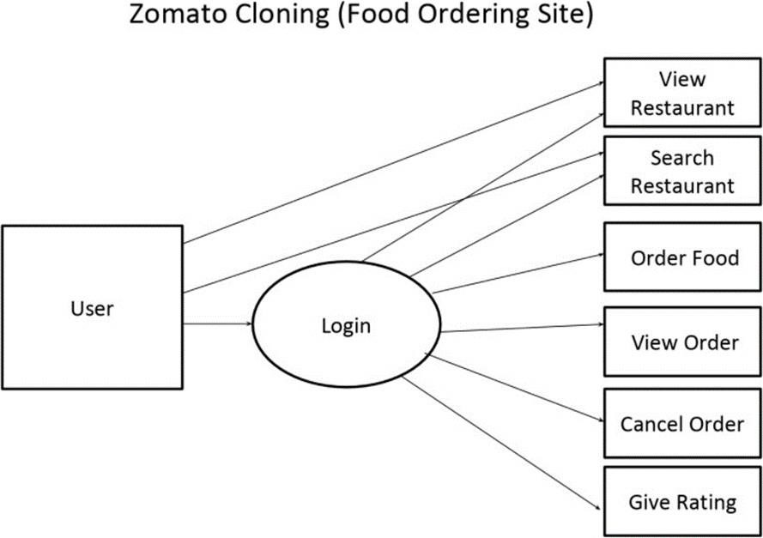

Fig 1.2

# CHAPTER-3

## SYSTEM SPECIFICATION

Functional and nonfunctional requirements were used to categorize the system's requirements.

**SOFTWARE REQUIREMENTS SPECIFICATION**

**Hardware Interface:**

* + Processor: All Pentium series
  + RAM: 1 GB (Min.)

#### Software Interface:

* + Operating System: Above Windows 7
  + Backend: Node.JS, Express.JS, and MongoDB
  + Frontend: React.JS, HTML, CSS, JavaScript, and Bootstrap

## Functional Requirement

The following features are desired for the new system. The planned project would consist of the following:

Without logging in, customers can view menu items and search for desired food items.

If a consumer tries to add the same menu item more than once, they can add or remove it from their cart without logging in. It will only add one.

The customer must log into the system before trying to make a purchase.

He or she can place an order after creating an account and logging into the system.

If a consumer clicks the "Pay" button, their order will be placed and their payment will be accepted.

The orders button allows customers to view the details of their orders.

Customers can view the order status for each order (Pending, Confirmed, Delivered) Customers can download their order invoice for each order

Customer can rate food item

### Non-functional Requirement

It details a software system's quality attribute. They assess the software system according to non-functional criteria such as responsiveness, usability, security, portability, and other criteria that are essential to the software system's success.

Availability: The system should continue to function at all times and in all locations.

Accuracy: The system needs to be optimized to produce more precise computations and outcomes.

Usability: To improve itself and be more responsive, the system should offer a user- friendly user interface and tooltips.

Secure: By utilizing a tiered security approach, the system must be able to ensure protection against any external injections. By implementing user login features, the system is protected against unauthorized users.

System performance: For the given task, response time is excellent. The technology will handle environments with multiple users.

System reliability: The system is very dependable and generates all the latest information in the right sequence. At every level of an activity, data are validated and verified.

## TECHNOLOGY USED

“The foundation of websites is provided by HTML, which is then improved and altered by other technologies like CSS and JavaScript.

Layout, formatting, and presentation are all managed via CSS. JavaScript used to regulate how certain elements behave.”

### HTML

HTML is the industry-standard markup language for developing online pages and web applications. It is one of three foundational technologies underpinning the World Wide Web, along with JavaScript and Cascading Style Sheets (CSS). HTML documents are received by web browsers from a web server or local storage and are then rendered into multimedia web pages. HTML originally provided hints for the document's appearance in addition to semantic descriptions of a web page's structure.

The foundation of HTML pages are HTML elements. Images and other objects, like interactive forms, may be embedded within the rendered page using HTML constructs. By designating structural semantics for text elements like headings, paragraphs, lists, links, quotations, and other objects, HTML gives users the ability to create structured documents.

Tags, which are written in angle brackets, are used to distinguish HTML elements. Importing content into the website is made easy with tags like "img" and "input." Other tags, like p>.../p>, surround the text of the document and provide information about it. They may also contain other

tags as sub-elements. The HTML tags are used by browsers to interpret the content of the page but are not displayed.

HTML allows for the insertion of scripts written in languages like JavaScript that modify the behaviour and content of web pages. CSS defines how content is presented and how it is organised. Since 1997, the World Wide Web Consortium (W3C), which oversees the HTML and CSS standards, has promoted the use of CSS instead of explicit presentational HTML.

### Cascading Style Sheet (CSS)

Cascading Style Sheet web page layouts employ CSS. They can be used to create font styles, table sizes, and other Web page elements already described in HTML.

CSS makes Web pages look uniform. Common styles can be defined once in a CSS sheet rather than writing it again and again. Any page that references the CSS file can use the style defined in cascading style sheet. CSS simplifies style changes across several pages. For ten Web pages, a developer may want to change the margin from 10px to 15px . If all pages use the same style sheet, changing the margin on the style sheet makes change on all pages.

CSS is fantastic for text styles, but it also helps format Web page layout. CSS can determine table cell padding, border style, thickness, and colour, and image or object padding. CSS provides more precise control over Web page appearance than HTML. This is why most websites use cascading style sheets.

#### Advantages of CSS:

CSS is the web's most used style language. I'll list some:

Reusing CSS saves time: Each HTML element can be styled and applied to multiple Web pages. CSS reduces HTML tag attributes, making pages load faster. Apply one CSS rule to all tag occurrences. Less code speeds downloads.

Easy maintenance: Change the style to update all web page elements globally.

Better styles than HTML: CSS contains more characteristics than HTML, so you can style your HTML page better.

Style sheets enable multi-device optimization: The same HTML document can display separate website versions for handheld devices like PDAs and

cell phones or for printing.

Global web standards: HTML attributes are deprecated and CSS is encouraged. For future browser compatibility, all HTML pages should include CSS.

### Bootstrap

Bootstrap is an open-source toolkit for responsive web design. The most popular HTML, CSS, and JavaScript framework for responsive, mobile-first websites. Websites are now compatible with IE, Firefox, and Chrome on all screen sizes (Desktop, Tablets and Phones). Mark Otto and Jacob Thornton of Twitter developed Bootstrap, which was later made open-source.

#### Why bootstrap?

Web-Development is faster and simpler. It builds platform-independent websites. It develops responsive websites.

It creates mobile-responsive websites.

It's free and open-source at [www.getbootstrap.com.](http://www.getbootstrap.com/)

#### Benefits of using Bootstrap:

Fewer cross-browser bugs

A consistent framework supporting most browsers and CSS compatibility fixes Flexible and light

Responsive designs

jQuery-based JavaScript plugins

Well-documented and community-supported

Free and premium WordPress themes, plugins, and templates Excellent grid

### JavaScript

JS is a high-level, interpreted programming language. The language is dynamic, weakly typed, prototype-based, and multiparadigm. JavaScript is one of three essential Web content engineering technologies, along with HTML and CSS. It creates dynamic web pages and

provides interactive online programs, including video games. Most websites use it, and modern web browsers support it without plug-ins using a built-in JavaScript engine. All JavaScript engines are based on the ECMAScript specification; however, some support the language fully and several support capabilities beyond ECMA. JavaScript supports event-driven, functional, imperative, object-oriented, and prototype-based programming paradigms. It offers an API for working with text, arrays, dates, regular expressions, and rudimentary DOM manipulation, but it does not have I/O like networking, storage, or graphics. Instead, it relies on the host environment. JavaScript engines are currently incorporated in many types of host software, including server-side in web servers and databases, non-web programmes like word processors and PDF software, and runtime environments for creating mobile and desktop apps, including desktop widgets.

JavaScript was influenced by Self and Scheme, yet the two languages are very different. Google Chrome's JavaScript Engine powers server-side platform Node.js (V8 Engine). Ryan Dahl created Node.js in 2009. Its newest version is 14.13.0. Official documentation defines Node.js as follows.

#### Node.js

Technology Used

Node.js is a cross-platform, open-source runtime for server-side and networking applications. JavaScript- based Node.js apps can run on OS X, Windows, and Linux. Node.js' large JavaScript module library simplifies web application development.

**Node.js = Runtime Environment + JavaScript Library**

### Features of Node.js:

The following are just a few of the many reasons why Node.js is the preferred platform for new software projects.

Non-blocking and asynchronous - All of the Node.js library's application programming interfaces (APIs) are asynchronous. When using Node.js, a server will never have to wait for an API to return data. After calling an API, the server moves on to the next one. A Node.js feature called Events helps the server get a response from the last API call.

Due to its foundation in the V8 JavaScript Engine used by Google Chrome, the Node.js library provides lightning-fast performance.

Node.js employs a single-threaded paradigm with event looping, which makes it extremely scalable. Unlike typical servers, which produce a finite number of threads to process requests, a server that uses an event system to respond to requests can scale very efficiently. Unlike traditional servers

like Apache HTTP Server, Node.js's single-threaded software can handle many more requests at once.

No Buffering Node.js applications never buffer data. Such applications only deliver the information in chunks.

Node.js is open-source software that is released under the MIT license.

#### Tech giants use Node.js:

Here's a link to a wiki on GitHub that lists every known project, app, and company that employs Node.js.

Companies like eBay, GE, GoDaddy, Microsoft, PayPal, Uber, Facebook, Yahoo!, and Yammer are just a handful on this list.

#### Concepts

The following diagram illustrates some of the more vital parts of Node.js.

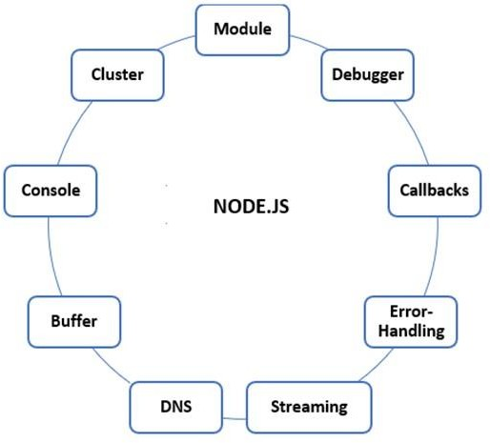

#### Fig 1.3

**Node.js: Where to use?**

The following are some of the application domains in which Node.js is proven itself to be an ideal technological partner.

I/O-bound apps, Data-streaming apps,

DIRT (data-intensive, real-time),

JSON API apps, Single-page apps

### Express.js

Express is a web application framework for Node.js that is both lightweight and adaptable, yet offers a full suite of tools for creating both desktop and mobile apps. Faster creation of Node-based web apps is made possible. A few of Express framework's most prominent characteristics are as follows:

* + Enables the setup of middleware to handle HTTP requests.
  + Defines a routing table used to carry out various operations depending on the HTTP Method and the URL.
  + Enables the dynamic rendering of HTML pages using arguments passed to

### React.js

templates.

ReactJS builds reusable UI components in JavaScript. React is a library for composable user interfaces, per its official documentation. It promotes reusable UI components that display dynamic data. React is the MVC V for many. React makes programming easier and faster by abstracting the DOM. React can also render on the server using Node, and using React Native, it can power native apps. One-way reactive data flow in React eliminates boilerplate and makes data binding easier to understand.

#### Features:

JSX - JavaScript syntax extension. React development doesn't require JSX, but it's recommended.

Components - React is about components. Everything should be considered a component. This will aid code maintenance on larger projects. Unidirectional data flow and Flux - Since React only allows data to flow in one direction, it's easy to understand how your app works. Flux keeps data

unidirectional.

 License - React is licensed by Facebook Inc. The documentation is licensed under CC BY 4.0

Advantages of using React.js

Uses a JavaScript object called virtual DOM. JavaScript's virtual DOM is more efficient than the standard DOM, so this will boost app speed.

As well as being compatible with other frameworks, it may be used on both the client and server sides.

Readability is enhanced by component and data patterns, which facilitates the upkeep of larger applications.

#### Limitation of using React.js

Only addresses the app's view layer; additional technologies are required for a full set of development tools.

### MongoDB

Some programmers may find the use of inline templating and JSX to be cumbersome.

MongoDB is the leading open-source NoSQL document database. MongoDB is written in C++. MongoDB, a cross-platform, document-oriented database, is fast, reliable, and scalable.

Document and collection are MongoDB's foundation.

#### Database

Databases are physical containers for collections. Each database has its own file system files. MongoDB servers usually have many databases.

#### Collection

Collections are MongoDB documents. Like an RDBMS table. Collections are stored in databases. Collections are schema-free. Collection documents have distinct fields. A collection's documents are usually related.

## Document

Documents are key-value pairs. Documents have a dynamic schema. Dynamic schema allows common fields in a collection's documents to carry multiple sorts of data.

Table 4.1 below shows how RDBMS terminology relates to MongoDB. The structure of a single object is clear.

Simple joins.

Extensive query ability. MongoDB's document-based query language supports dynamic document queries.

Tuning.

MongoDB scales well.

No application-to-database mapping required.

Uses internal memory to store the (windowed) working set for faster data access.

#### Why MongoDB?

Document-oriented storage - stores data as JSON documents. Index any attribute

Auto-Sharding, Rich Queries,

Fast In-Place Updates, and MongoDB Professional Support

#### Uses of MongoDB

MongoDB is used in multiple domains. Some of the key domains, where MongoDB is used are:

MongoDB can be used in a variety of technologies, including:

Cloud computing: MongoDB can be used in cloud-based environments,

such as Amazon Web Services (AWS) and Microsoft Azure, allowing for easy scalability and high availability.

Microservices: MongoDB can be used as a data store for microservices- based architectures, allowing for easy data sharing and communication between microservices.

Artificial Intelligence and Machine Learning: MongoDB can be used to store and retrieve large amounts of data that is used for training and validating machine learning models.

Real-time streaming data: MongoDB can be used to store and retrieve real- time streaming data, such as sensor data, making it a good choice for IoT and streaming analytics applications.

Containerization: MongoDB can be easily containerized and deployed in a variety of container orchestration platforms such as Kubernetes, Docker Swarm, and Mesos.

Serverless: MongoDB can be used in serverless architecture with the help of cloud-provided services like MongoDB Atlas or AWS DocumentDB, allowing for on-demand scaling and pay-per-use pricing modelsData Hub

## Chapter-4

**SOFTWARE DEVELOPMENT PROCESS MODEL**

During the software development process, many software development methodologies are established and designed, often known as "Software Development Process Models." Each process model relies on a unique life cycle to guarantee the quality of the software being developed.

A software process model is a framework that describes the activities and tasks that are performed during the software development life cycle. It provides a roadmap for how software should be developed, tested, deployed, and maintained. There are several different types of software process models, each with its own set of characteristics and best practices.

Some common software process models include:

Waterfall: This is a linear, sequential model in which development proceeds through distinct phases, such as requirements gathering, design, implementation, testing, and maintenance.

Agile: Agile software development is an iterative, incremental approach that emphasizes rapid prototyping, flexible planning, and adaptive development.

Spiral: Spiral model is a process combining the iterative nature of the Agile development with the systematic and controlled aspects of the Waterfall model. It's applied for high- risk projects.

1. Model: A V-shaped model which is an extension of the waterfall model that includes specific testing and validation activities at each phase of development.

Each software process model has its own advantages and disadvantages, and the choice of model will depend on the specific characteristics of the project. All models are different in their approach but all have the same goal: to deliver a high-quality software product on time and on budget.

### SDLC Model Used:

The Iterative development model is a software development approach in which the development process is divided into multiple iterations or cycles. Each iteration involves a series of activities, including planning, design, implementation, testing, and evaluation. The goal of each iteration is to deliver a working version of the software that has a limited set of functionalities.

The main characteristic of the Iterative model is that it allows for changes and revisions to be made throughout the development process. Unlike the Waterfall model, which requires that all requirements be gathered and understood before development begins, the Iterative model allows for the gathering and understanding of requirements to occur incrementally.

This approach allows the developers to adapt to changing requirements and feedback from users, so it is well suited for projects with high levels of uncertainty or change.

Iterative development is often preferred when the requirements of the system are not completely understood at the beginning of the project, and when a working version of the system is needed as soon as possible. It also allows for better risk management since it addresses potential problems early on in the development process.

#### Iterative Model Phases:

The phases of the iterative development model are:

Software Development Process Model

* 1. Requirement collection and analysis: An analyst gathers customer needs and determines if they will be met. Analyst verifies budgetary feasibility. After this, the software team advances.
  2. Design: Data Flow, activity, class, state transition, and other

diagrams are used to design the software.

* 1. Implementation: Software is created from requirements specified in coding language.
  2. Testing: Software testing begins after coding. White, black, and grey box tests are the most prevalent.
  3. Deployment: After all processes, software is installed in the workplace.
  4. Review: After product deployment, product behavior and validity are reviewed.

Errors restart the procedure from requirement gathering.

* 1. Maintenance: After software deployment, bugs, errors, and updates may arise. Maintenance includes debugging and adding options.

It's worth noting that the names and number of these phases might vary depending on the method or framework that you are using, but the concept and goal of each phase remain the same. The goal of the iterative development model is to deliver a working software incrementally, incorporating feedback and changes with each iteration, until the final product meets the customer's requirements and expectations

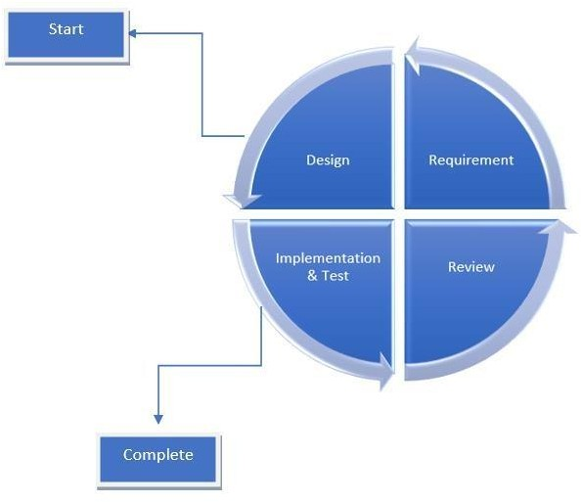

**Fig 1.4**

## DATABASE (MongoDB)

### 2.1. MongoDB

MongoDB is a NoSQL, document-oriented database that stores data in collections.

A collection in MongoDB is a group of documents that have a similar structure. Each document in a collection is a set of key-value pairs, where the key is a string and the value can be any valid BSON (Binary JSON) type. These documents can have different fields and structures, but generally, they have something in common, like for example, the same type of entities or the same purpose.

A collection in MongoDB can be created by using the ***db.createCollection()*** method. This method takes one argument, which is the name of the collection to be created. Once the collection is created, it can be manipulated and queried using a variety of methods such

as:

##### db.collection.insertOne(), db.collection.find(), db.collection.updateOne(), db.collection.deleteOne(), db.collection.aggregate(), db.collection.count(), db.collection.distinct() and so on.

Collections are similar to tables in relational databases, but they have more flexibility in terms of data modeling and can store data in more complex structures. In MongoDB, you

don't need to specify the schema of a collection upfront, allowing you to store data in a more dynamic way.

The documents in a collection can have different structure, MongoDB will not enforce any type of strict schema and this can be both a benefit and a drawback. In one side it's great to store different types of information without the need to design a schema upfront, however it could lead to difficulties when querying the data, since it's not guaranteed that each document will have the same fields.

A collection also have some additional properties, one of the most important is the capped property, which allows to specify that a collection should have a fixed size. This feature is useful when you need to maintain a log of recent events, like for example, to keep a record of the last 1000 events that occurred in a system.

Indexing is also very important when working with MongoDB collections, by default each collection is created with a unique index on the "_id" field, however you can create additional indexes on any other fields you want to improve the performance of your queries.

It's important to note that MongoDB collections don't enforce any type of strict schema, this means that you can insert any kind of document with any structure into a collection, that's why MongoDB collections are also known as schema-less collections. This can lead to flexibility but also to a less-structured data, which could make querying and indexing more complex.

The following are the list of collections used in the project:

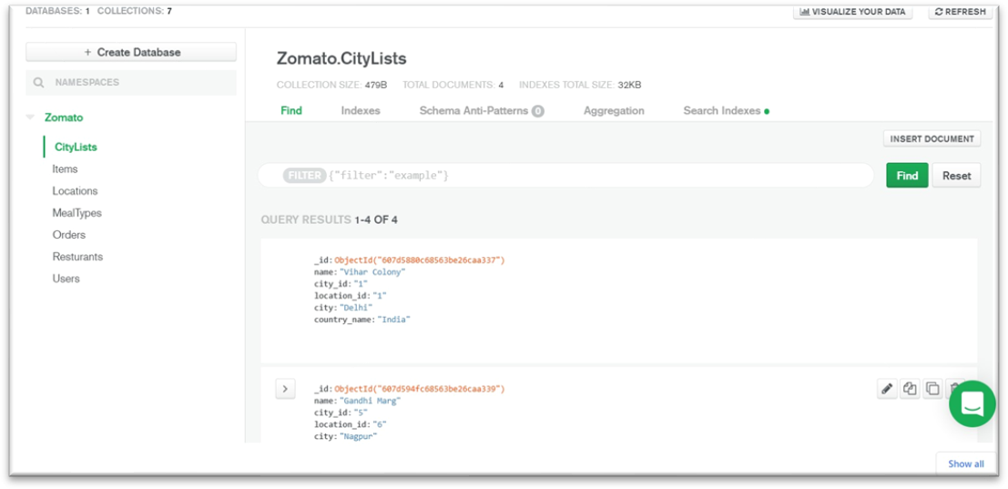

**Fig.2.1.**Depicts the collection **CityLists**, which have various fields such as

**name**, **location**, **country_name,** etc.

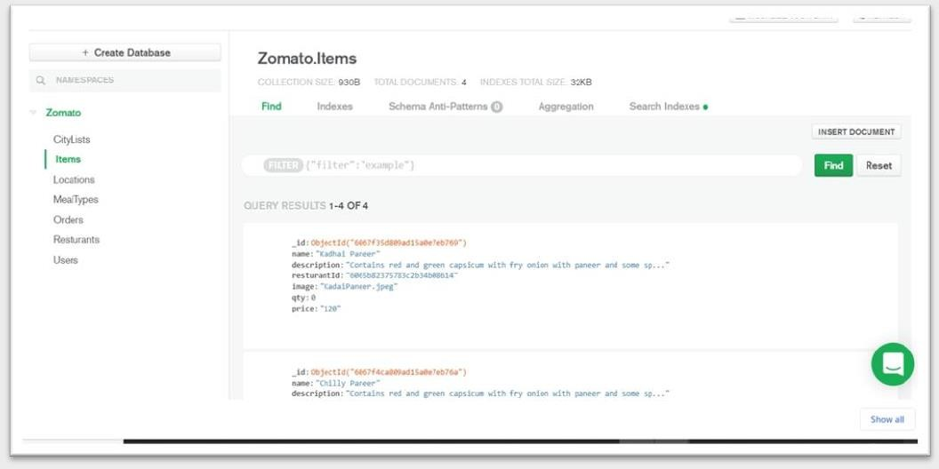

**Fig.2.2.**Depicts the collection **Items**, which have various fields such as

**name**, **description**, **restaurant name**, etc.

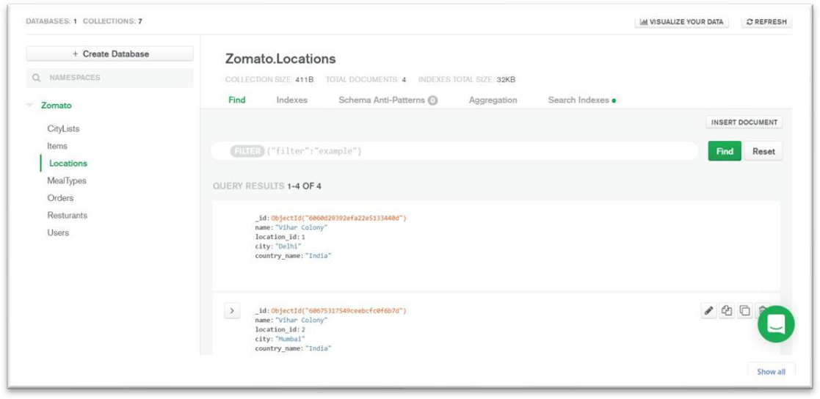

**Fig.2.3.**Depicts the collection **Locations**, which have various fields such as

**name**, **location_id**, **city**, etc.

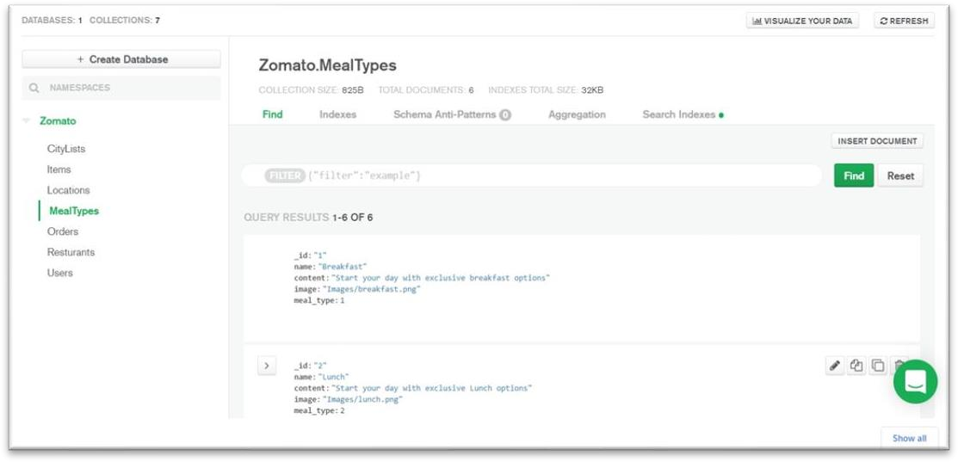

**Fig.2.4.** Depicts the collection **MealTypes**, which have various fields such as

**types of meal, description of mealtype**, **image**, etc.

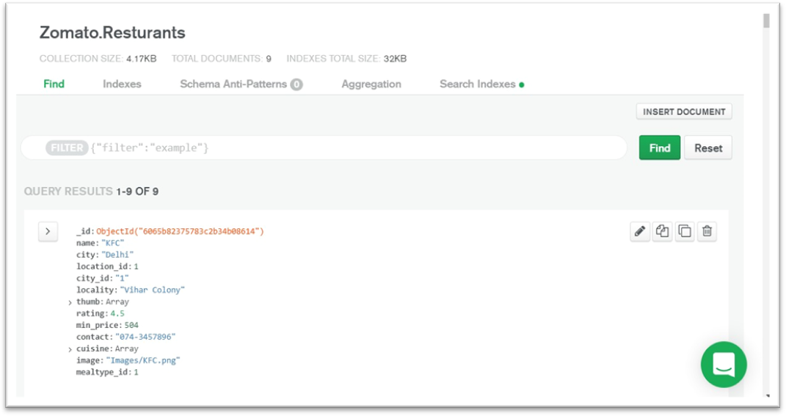

**Fig.2.5.**Depicts the collection named **Restaurants**, which have various fields

such as the **name of restaurants, place of restaurant, locality, list of cuisine**, etc.

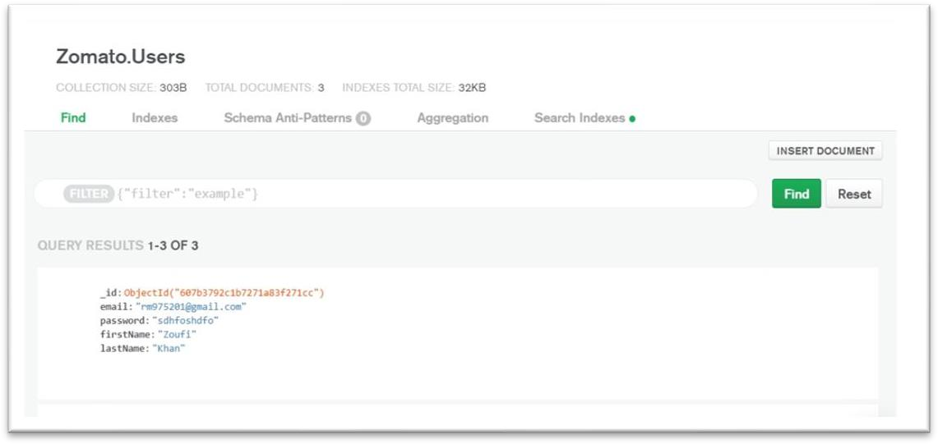

**Fig.2.2.**Depicts the collection **User**, which has various fields such as the **email of the user, name of the user, user id,**etc.

### 3.1. User Interface (UI)

The user interface (UI) of the website is designed to make it easy for users to navigate and interact with the app or website. The UI typically includes a navigation bar, search bar, and a variety of buttons and links to access different features and pages. The layout is visually appealing with a clean and modern design and uses a color scheme that is

consistent throughout the app. The UI is also designed to be responsive, meaning it adjusts to fit the screen size of the device it is being viewed on. The UI features are designed in a way that it's easy to understand and interact with, making it easy for users to find and order food from their favorite restaurants. The UI is also designed to be user- friendly, with intuitive navigation and simple, easy-to-use controls.

Following are the screenshots of the developed project:

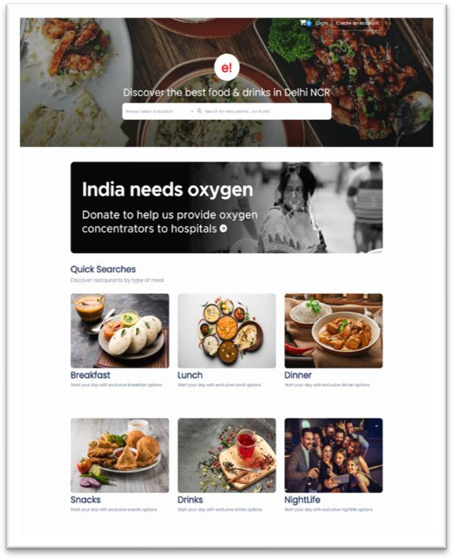

**Fig.3.1 Home Page of the website**

A home page of the website is the landing page of the website or mobile application. It typically displays a search bar for users to find restaurants or food options in their area, as well as featured restaurants or popular choices. The home page may also include links to other sections of the website, such as menus, reviews, or rating. Additionally, a user can log in or sign up for an account on the home page, to place an order. Overall, the home page serves as a hub for users to easily navigate and access the various features and services offered by product.

*User Interface (UI)*

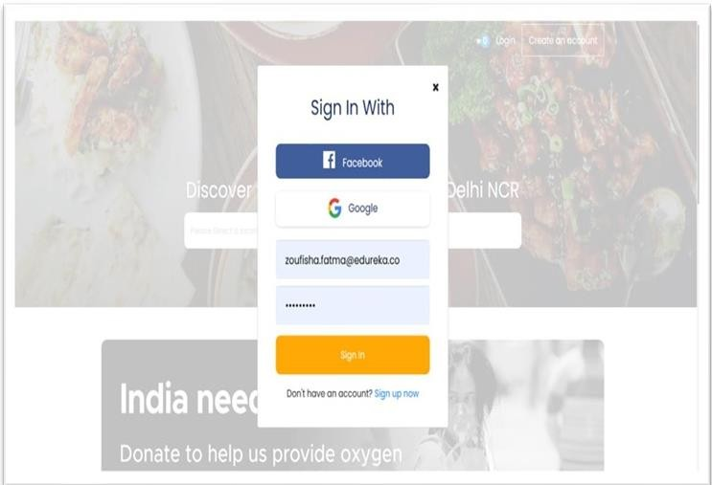

**Fig.3.2 Login Page of the application**

The login page of the website is a feature that allows registered users to access their account and personalize their experience on the website or mobile application. This page typically includes fields for users to enter their email address or phone number and password, as well as a button to submit the login request. Users can also click on the “forgot password” link if they have forgotten their password and need to reset it. Additionally, the login page might also include an option for users to sign up or create an account if they are not already registered. By logging in, users can access their saved preferences, order history and also search their favorite

restaurants. The login page serves as a portal for registered users to access their account and personalize their experience on the website.

This is the login page of our website where we give three ways to user for login into website:

* Using social media login (Google and Facebook)
* Using valid credentials which user enters at the time of login

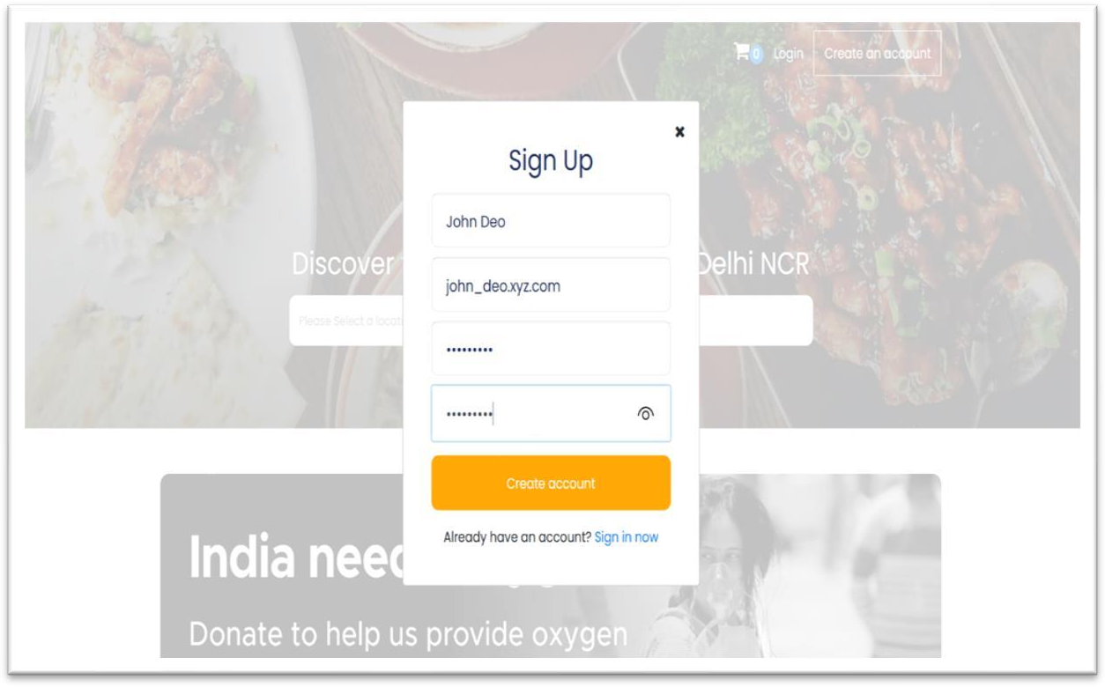

**Fig.3.3 Sign Up Page of the application**

A sign-up page on the website is where users can create a new account in order to use the platform. The page typically includes fields for the user to input their email address and password, as well as any other required information such as name and contact details. Users may also have the option to sign up using their existing Google or Facebook accounts. Once the user submits their information, they will be login into their account using those credentials. Once they login using, their credentials, users will have full access to the website's features and services.

*User Interface (UI)*

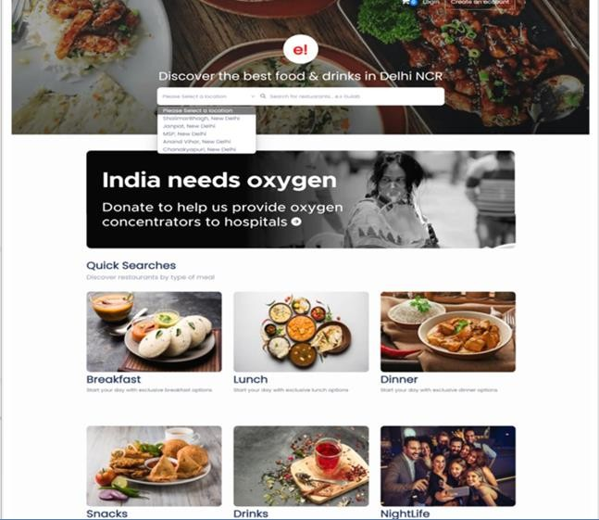

#### Fig.3.4 Search by Locations Dropdown

A search by-location drop-down in The website allows users to search for restaurants, cafes, and other food establishments in a specific geographic location. The user can select a location from a drop-down menu, which may include options such as cities, areas, or landmarks. Once a location is selected, the search results will be limited to the chosen location, making it easier for the user to find a restaurant nearby. Some other search filters like Cuisine, Sort, Cost and more can also be used to refine the search.

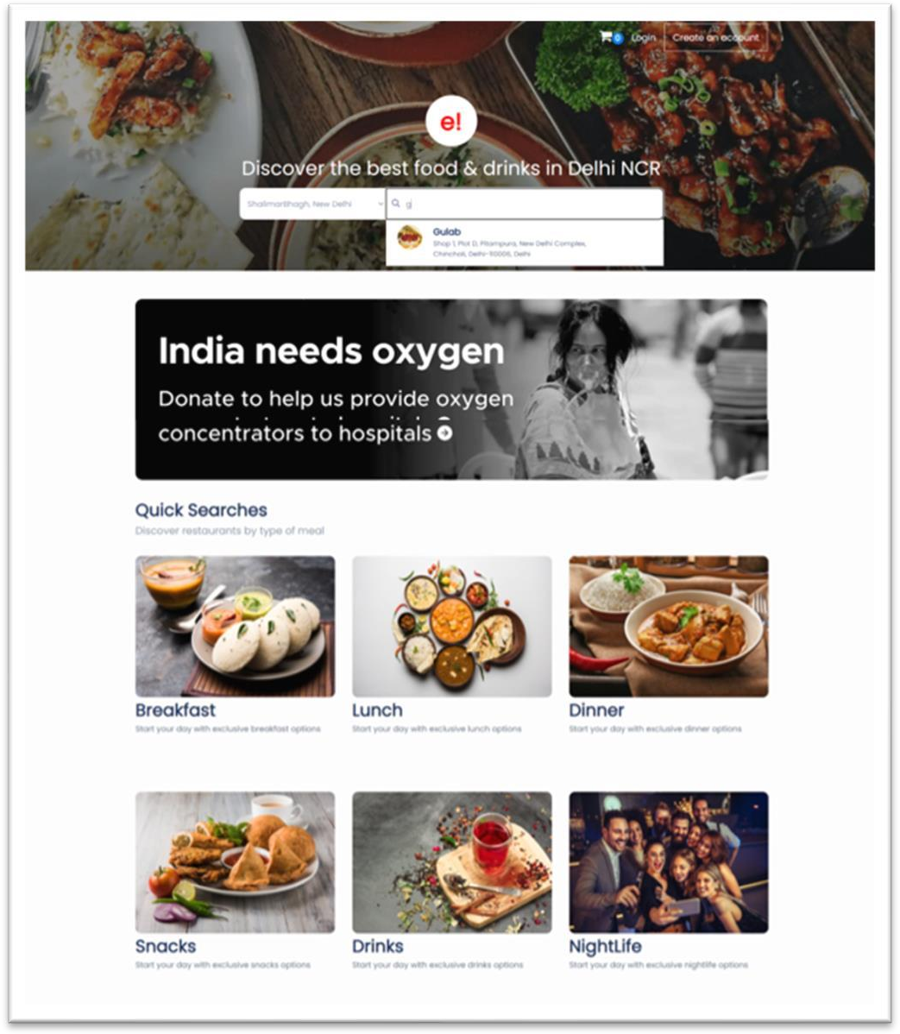

#### Fig.3.5 Suggestion Logic in Homepage

When a user selects a location from the location drop-down menu in The website, the website will display a list of suggested restaurants based on that location. These suggested restaurants are typically chosen based on factors such as popularity, customer ratings, and proximity to the selected location. The suggested restaurants are usually displayed in a list format, with each restaurant’s name and detailed address. Users can also find more details by clicking on the restaurant name to see its menu, photos, reviews, and contact information. It is a great way to find the best restaurants in a given location and also save time in searching for restaurants.

Applied using sliders and some using drop down options. This feature is useful for users who have specific preferences or are looking for a specific type of restaurant.

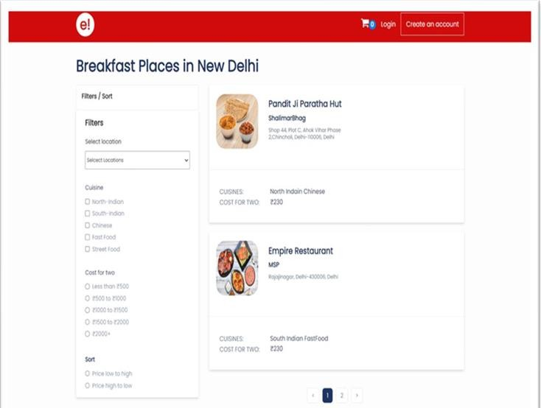

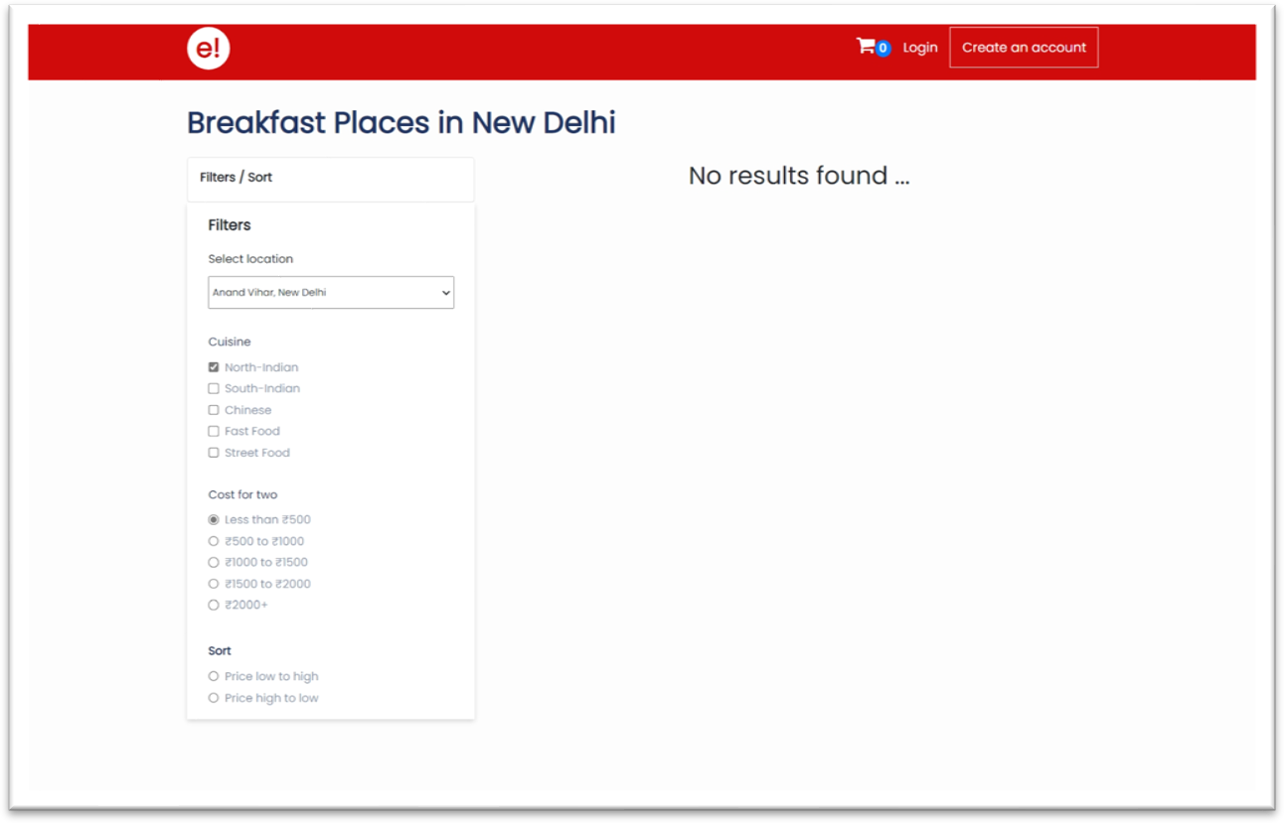

#### Fig.3.7 No results found

The “No results found” screen in the website is displayed when the website is unable to find any restaurants that match the user’s search criteria. This can happen when the user has entered an incorrect location, or when there are no restaurants in the chosen location that match the user’s other search filters (such as cuisine, rating, and cost range).

When this screen appears, it usually contains a message indicating that no matching results were found and a suggestion to broaden the search by either changing the location or modifying the search filters.

It also includes an option to search again using different or modified filters or location. Users can also try searching with a broader location or a different spelling of the location they are searching for.

#### Fig.3.8 Details Page of the application (Tab and Contact View)

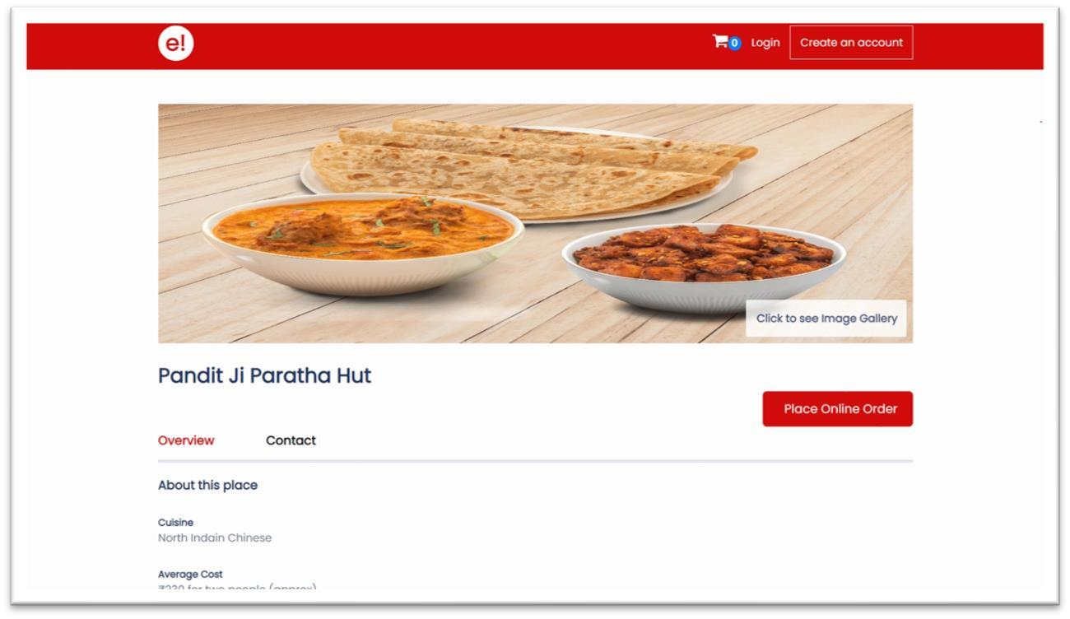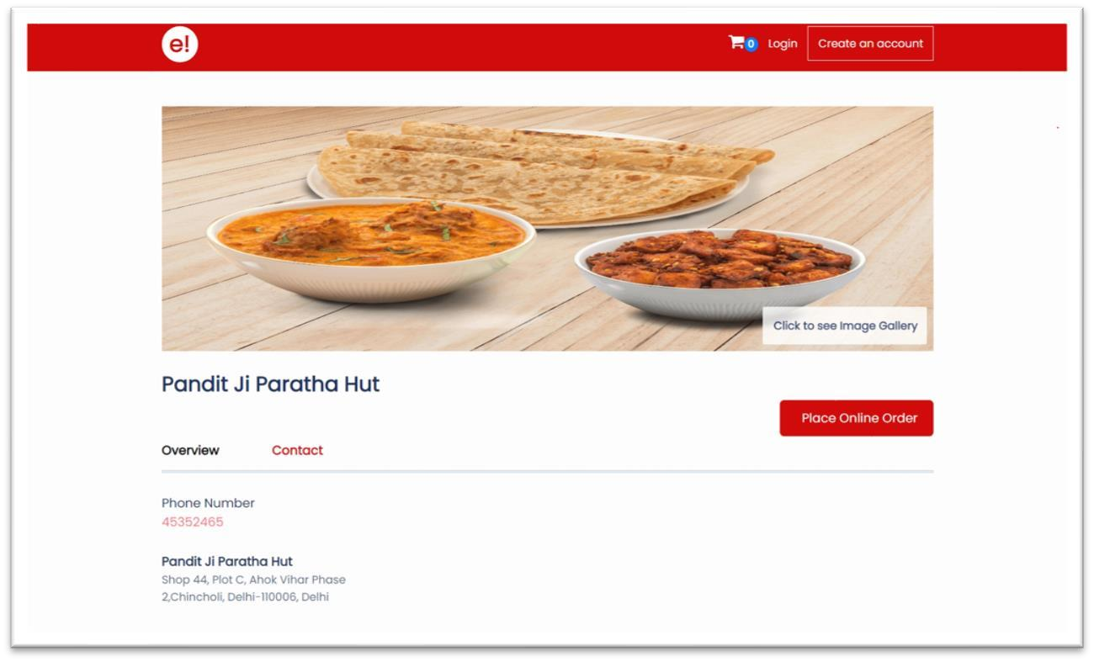

The details page in the website is a feature that provides users with comprehensive information about a specific restaurant. When a user clicks on a restaurant name in the search results or suggested restaurants, they will be taken to the details page for that restaurant. This page typically includes information such as the restaurant’s name, address, phone number, etc.

It also contains user reviews, ratings, photos, cuisine, cost range, and more. Users can also find options to see the menu and desired food items. It also allows users to make an informed decision about whether the restaurant is a good fit for their needs.

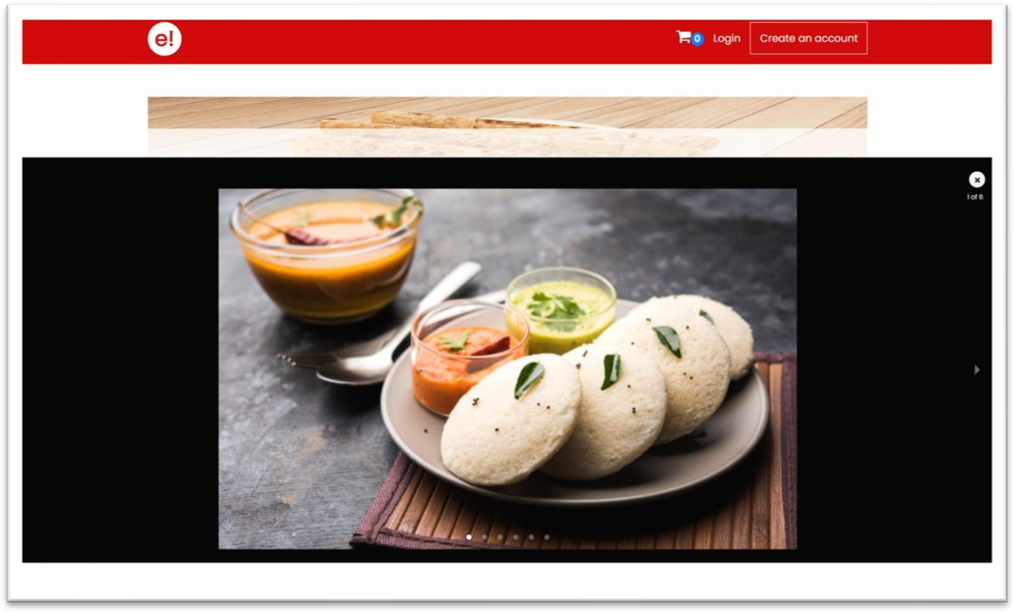

#### Fig.3.9 Image Gallery option of Details page

An image gallery in the website is a feature that allows users to view images of food, drinks, and restaurant interiors. These images can provide a visual representation of the menu items and atmosphere of a restaurant.

*User Interface (UI)*

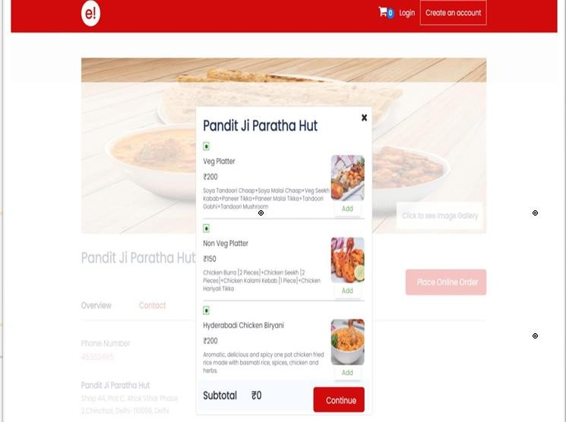

#### Fig.3.10 Menu Window

A menu pop-up window in the website is a feature that allows users to view a restaurant’s menu without leaving the current page. This can be useful for quickly checking prices or ingredients without having to navigate away from the restaurant’s profile or search results. The menu pop-up window can be accessed by clicking on Place Online Order, which typically includes a list of food and drink items with prices. It also may include images of menu items and allows users to select menu items as per their craving.

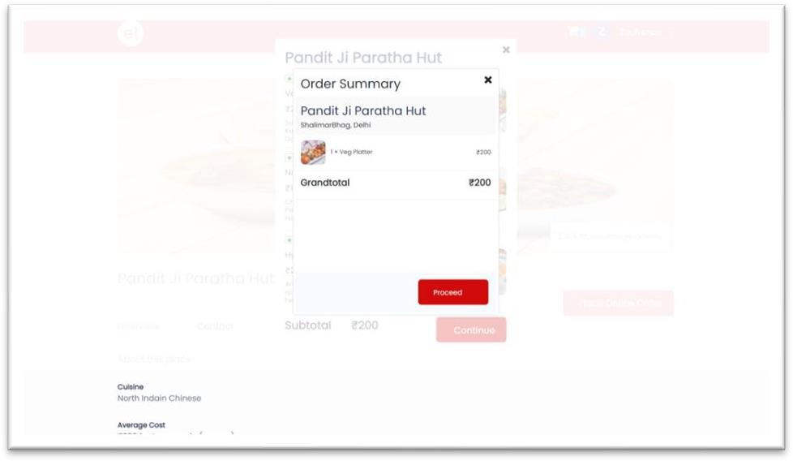

#### Fig.3.11 Order summary screen

An order summary pop-up window in the website is a feature that allows users to review the details of their food or drink order before placing it. This includes items and quantities, the grand total of the order.

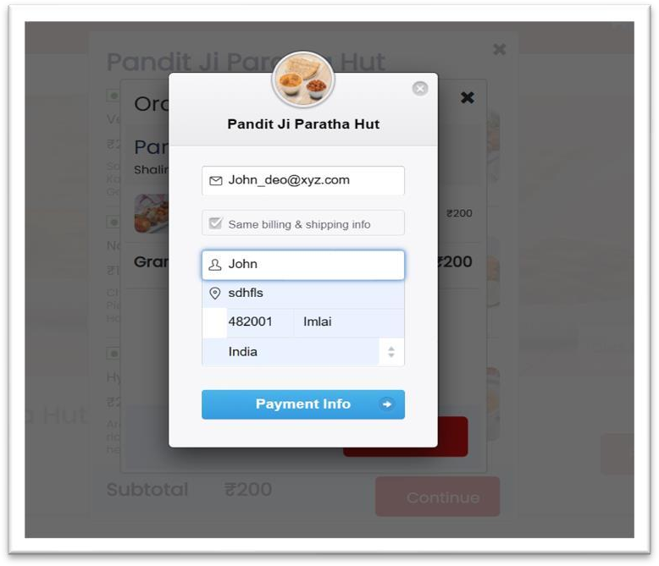

#### Fig.3.12 Billing and shipping screen

The billing screen in the website is a feature that allows users to fill billing and shipping details before placing the order. This includes email, name, billing and shipping address.

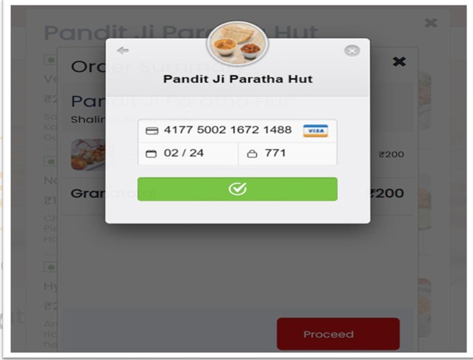

#### Fig.3.13 Payment window

It allows users to complete the payment process for their food or drink orders. This includes selecting a payment method, entering payment details and processing the payment. Payment methods accepted on the website is using credit/debit cards only. The payment window is typically accessed after the user has reviewed their order and billing details, and is presented as a pop-up within the the website app or website. After the payment is processed, the user will check the placed order in cart.

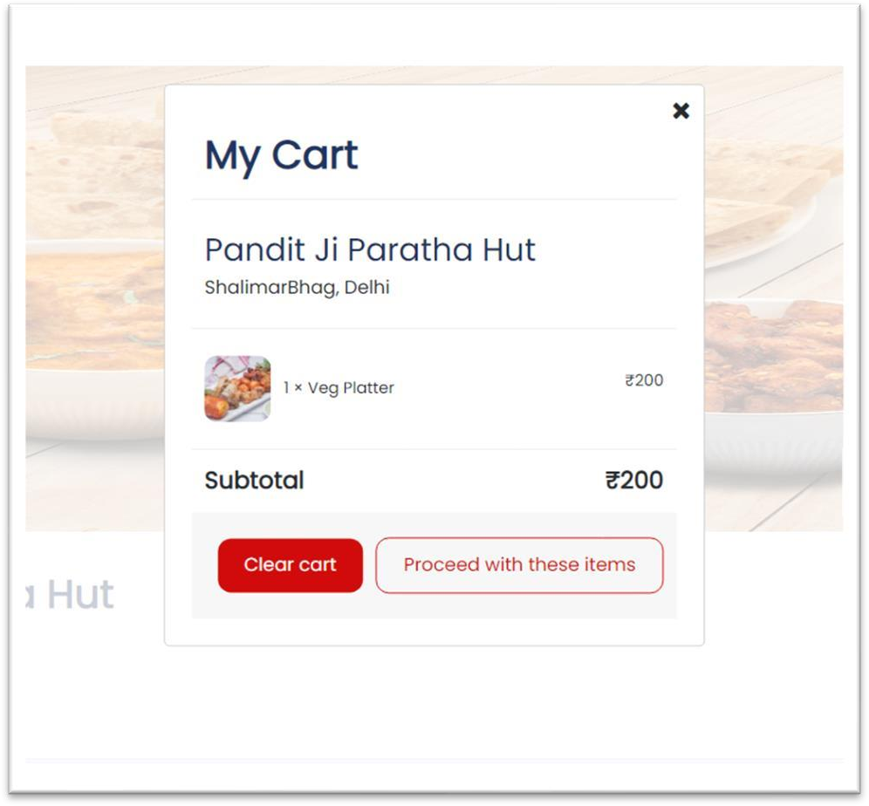

#### Fig.3.14 Cart window

It allows users to view the details of their recently placed food or drink order. This includes the list of items and quantities, total, and option to proceed with same items.

## TESTING

In Software Engineering, "Testing" refers to the process of assessing whether or not a given software implementation satisfies a set of predetermined criteria. The features of the software product are tested to ensure that they meet all specifications, including those for accuracy, reliability, and performance.

Testing is a set of methods to check the application's correctness under a script, but it can't find all the flaws. Testing is used to find and fix application errors. It merely shows that a product doesn't work in some scenarios.

Testing compares software behavior and state to mechanisms because mechanisms can identify problems. The method may comprise past versions of the same specified product, comparable products, interfaces of intended purpose, relevant standards, or other criteria, but not restricted to these.

Testing involves code inspection and execution in many contexts, situations, and code characteristics. In software development, a testing team may be independent from the development team to use testing data to improve the process.

Software success depends on user acceptability, easy graphical user interface, powerful functionality load test, etc.

#### TYPES OF TESTING

There are different types of testing, each with its own specific goal and methodology. Some common types of testing include:

* + **Manual Testing:** It is the process of testing a software application by manually performing a series of actions, such as inputting data, navigating through menus, and checking the results. It is typically performed by a human tester who follows a set of test cases or test scripts, it allows for more flexibility and can be used for exploratory testing, where the tester has a general idea of what to test but is not constrained by a predefined set of test cases.
  + **Automated Testing:** It is the process of using software tools to execute test cases and check the results. It allows for faster execution of repetitive tasks and reduces the chances of human error, it's commonly used for regression testing, where the same tests are run multiple times and for performance testing, where the system is subjected to high loads.
  + **White Box Testing:** It is a technique that examines the internal structure of the software and its code. This approach is also known as glass box or clear box testing. It involves testing the internal logic and code structure of the application, and it's often used to test the code coverage, verify if all the code is executed, check if all the paths are tested, and detect any logical errors. It's typically used by developers or programmers.
  + **Black Box Testing:** It is a technique that examines the external behavior of the software and its functionality. This approach is also known as functional testing, or behavioral testing. The tester has no knowledge of the internal workings of the software and only verifies that the application behaves as expected from a user's perspective. Black box testing is used to verify that the software is working as expected, that all the features are working correctly and that the application is reliable.
  + **Functional Testing:** It is used to verify that the system meets the requirements and that it works as intended. It includes testing the functionality of individual features, such as buttons and links, as well as the overall functionality of the application.
  + **Usability Testing:** It is used to evaluate the user-friendliness of the application and ensure that it is easy to use for its intended audience.

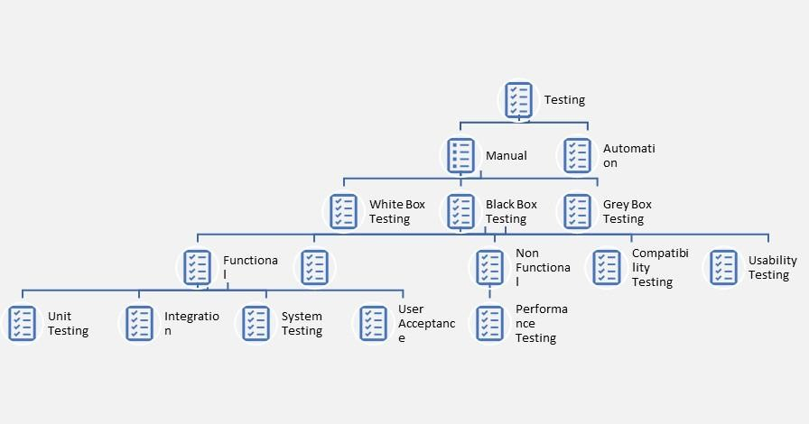

**Fig.4.1. Depicts the types of Testing**

**Testing Used**

#### Unit Testing

Unit testing entails testing each software application unit. It's the first level of functional testing. Unit testing validates unit components' performance. During application software development, a unit is a testable portion of the system.

Unit testing checks isolated code's correctness. An application function or code is a unit component. White box testing is used for unit testing by developers.

When the application is ready, the test engineer will start checking each component of the module or module of the application individually, which is called unit testing or components testing.

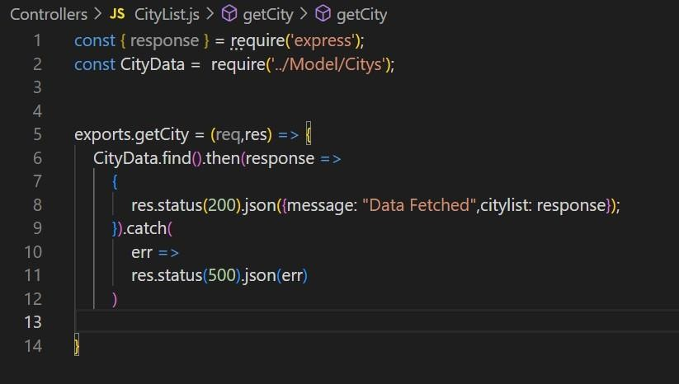

#### Fig.4.2. Depicts the unit testing of a function name getCity that returns the list of cities in success call of API

**Integration Testing**

After unit testing, software testing progresses to integration testing. In this testing, software modules or components are tested together. Integration testing detects flaws when integrated components interact.

Unit testing tests modules and integration testing tests them together. Software modules are coded by various programmers. Integration testing verifies module communication.

Integration testing checks data flow across dependent modules after all modules are working independently.

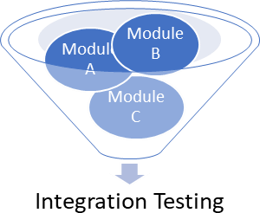

#### Fig.4.3. Illustrate the diagram of Integration

**testin**

## CONCLUSION

The website Food Ordering Web Application project was successfully completed. The system was developed with great attention to detail and was free of errors, as well as being efficient and time-efficient. The goal of the project was to create a web application for ordering items from a Food Ordering Website. Through this project, I gained valuable knowledge and hands-on experience in areas such as creating web pages using HTML and CSS, utilizing responsive templates using Bootstrap, designing a full-stack web application, and managing a database using MongoDB. The system is also secure. This project also taught me about the different stages of a project and the software development life cycle, as well as how to test various features of a project. I am pleased with the final product as it can be easily adapted for use by other restaurants or cafes that sell a variety of food items with minimal modifications. Despite the challenges that came with learning and developing using new technology, it was a valuable experience.

### FUTURE SCOPE

There are different types of testing, each with its own specific goal and methodology. There are room for growth and improvement in this project. In future, a number of features, such as tracking order delivery, can be added to this system. Also, Customer can be segregated into groups based on different filtering criteria so that different deals can be offered for each group. Machine Learning can be implemented to keep track of what each customer has bought in the past and make suggestions based on that for each customer.

## BIBLIOGRAPHY

1. K. Hassenzahl, M. Burmester, and G. Koller, “User experience - a research agenda,” in Human- Computer Interaction - INTERACT 2003, 2003, pp. 1–13.
2. S. Hassenzahl and M. Burmester, “The interplay of beauty, goodness, and usability in interactive products,” in Human-Computer Interaction - INTERACT 2007, 2007, pp. 691–700.
3. J. Schilit and A. Adams, “Context-aware computing applications,” in Mobile Computing Systems and Applications, 1994, pp. 85–90.
4. P. Kortum and S. Miller, “The effects of mobile technology on consumer purchasing behavior,” in Mobile Commerce, 2000, pp. 1–10.
5. J. Zhu and K. Rajasegarar, “The role of restaurant management systems in facilitating efficient and effective restaurant operations,” Journal of Foodservice Business Research, vol. 14, no. 2, pp. 136– 152, 2011.
6. J. Wang, S. Liu, and X. Li, “A restaurant management system based on mobile computing,” Journal of Foodservice Business Research, vol. 14, no. 3, pp. 212–221, 2011.